NCRT 6 ,11TH

NCRT 6,78,910TH

CONEPTUAL

Universe : , aestoried metroeried , meseorid, polar star,comet .

1. Universe: it limit less expanse of space surrounding us which consist of solar system stars and galaxies.
2. Universe consist of billions of galaxies and each galaxies billion of stars.
3. Spiral / elliptical ? irregular.
4. Orion sector.

Andromeda : brother galaxy.

pole stars

constellation Cassiopeia , group of star , ex great bear

solar system : it gravitationally bound system of sun and object it formed 1.6 billion years ago from the gravitational collapse of nebula . nebula is cloud of dust gasses and rocky substance .

nearly 97% of mass of nebula is in sun .

oort cloud which is hypothetical zone sun gravity.

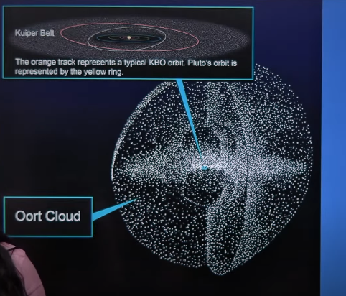

Asteroid belt and Kuiper belt

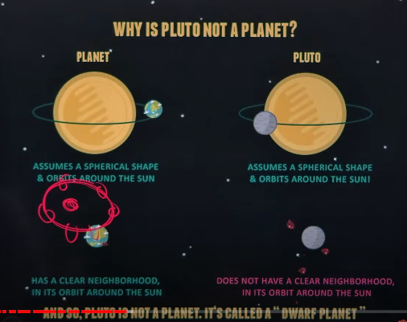

Planet and dwarf planet.

Planet : 1) it assume a spherical shape and orbits around the sun it has cleared its neighborhood in its orbits around the sun .

It is massive enough to clear its neighbourhood to be spherical shape under its gravitanal pull. Pluto

Name of dwarf: erua , pluto,eris,huama and teress

Kuiper blet it zone of numerous rockes beyond the Neptune pluto Is consider to be part of this zone.

Oort cloud : much larger belt it has gasses , dust and ice.

Difference inner planet and outer planet 1) the inner planet are rocky in the nature because it in close vicinity of sun it to warm to gasses to solid particle. 2 . Solar winds are more intense near the sun therefore it has blown a light gas like hydrogen and helium 3. tertial planet are smaller therefore it gravity is not hold the gasses.

Mercury: it smallest planet it not the hottest plant mercury has no moon thin atmosphere .

Venus : earths twin , same size and density of the earth Venus, toxic twin because sulphuric acid cloud.

Mars : it similar to the earth with respect to rotation. Mars 95% CO2 1% earth no water vapor very dry.

Far away.

Jupiter: largest planet, failed stars 2 twice as massive all the other planets combine it has giant storm great million year. NASA Juno is exploring this red spot.

Atmosphere: hydrogen helium,

Saturn: low density of planet .6 gram per cubic center miter.

Uranus: it is unique in its rotation as it tumbles it side its ice giant. It is the only Neptune: planet in the solar system that is not visible to the naked eye.

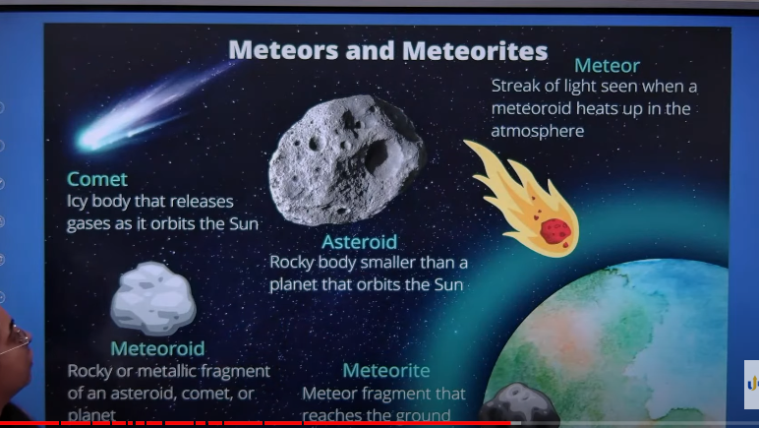

Meteoroids are lumps of rock and metal that orbits the sun. They found the thought the solar system forms the rocky inner planet or Kuiper belt.

Comet: they composed frozen gases together pieces of rock dust and metallic fragments when the gasses called to so much degree it become solidified (frozen gas ) as comet orbits closer to the sun the gasses heat up , starts evaporating and forms the tail comet generally originates from Kuiper belt and Oort cloud.

They are lumps of rocky planet and metallic fragments that orbits the sun and is found in path between mars and Jupiter

Main asteroid are ceres westa palasa. 50 mass of asteroid belt are found in previous 2 belt. Total mass of asteroid belt too mass the single planet and the gravity of Jupiter to form the single body against in the Jupiter gravity.

Meteorite. When meteoroids enter the earth’s atmosphere and burns up completely it meteor.

When meteor is not completely burn and it called meteorite. Lonar lake of Maharashtra is meteoroid created lake . in the India.

Pole star : pole start is stars nearly align with the axis earth. Earths norths pole stars Is polarus and it align approximately with north axis it serves permeant stars.

In the south there is no star as useful as Polaris . sigma octantis is closed naked eye stars to the south pole. (not visible clearly)

Formation of universe: not much is known about formation of universe. And there are many theory of universe,

study state theory, size of mass and energy constant .

Pulse hitting theory. Expand and contract.

Big bang theory.: it was propose by Jorge Lemaitre . according to theory universe was extremely compact in singularity

Infinitely dance ball and massive density huge mass and low volume. There was no matter no space and no time.

13.7 billion years ago a cosmic explosion happened ( big bang ) and tiny boll expanded in all the direction creating the fabric of space filled with energy and matter the matter was scattered in the form of nebula.

From that time the universe started to expand and continuing Hubble. In 1929 Propose that galaxy is moving away from each other. This is called phenomenon of red shift. The rate expansion of stars called as humble constant.

Interior of the earth.

Formation of solar system.

1. Solar system originating from 4.5 to 5 billion years ago most accepted theory is nebular hypothesis theory immnual kant and Laplace two mathematicians . solar system came from nebula (huge cloud of gas and dust) that began to contract due to own gravitational collapse.
2. The collapse of nebula formed the sun and it surrounded disk of gas and that eventually came together to form the plate
3. All the planet revolves on the same plane the same disk found the planet
4. The nebula hypothesis the layer nature of earth’s interior
5. Also explans the density increase inner of earth's

Q. how does Juno mission of nasa helps to understand the origin the evolution of earth.

Intro data for juno mission

Body

Conclusion.

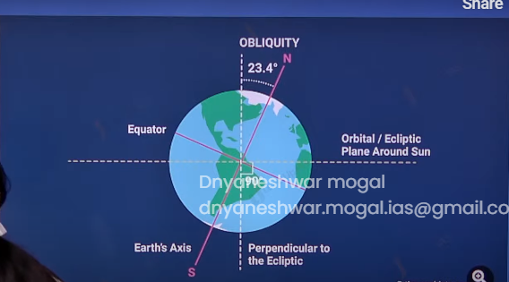

Asdf

Motion of earth

There are two basic movement

1. daily rotation on axis

2. annual revolution around the sun. along inclination and polarity.

1. earth rotation: earth rotation takes place 24 hours. The earth rotates west to east the tilt 23.5 from the line perpendicular to plane of ecliptic plane of solar system.

Effects of rotation:

1. Day and night
2. Because of rotation a fluid on the earth is deflected to the right in the northern hemisphere and left and southern hemisphere this is because of apparent force called as Coriolis force
3. Each place on earth can experience the tide because of earth rotation
4. The speed of rotation is maximum along the equator and decreases with increase in latitude.
5. There fore the satellite is launched close to the equator to provide initial thrust.

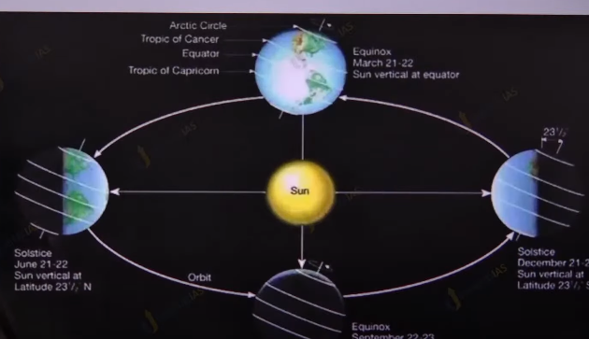

Revolution of earth:

1. Revolution time is 365 days
2. Revolution path by earth is not true circle but elliptical path because of elliptical path orbit earth and sun distance is not perihelion (3 jan) and is away during aphelion (3 july)
3. earth is 3.3 % closer to sun during the norther hemisphere winter than the during the norther hemisphere summer. The varying distance between the sun the earth is not playing the role in the seasons
4. seasons are formed because of factor like revolution inclination of earth axis and polarity no matter where the earth is while revolving around the sun the angle of tilted axis remains the same.
5. Two major reasons are revolution and tilted axis

Apparent shift of sun:

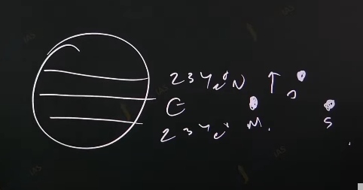

1. Due to revolution and tilted axis the sun appears between the sun
2. The tropic represent the farther limit which receive the direct of sun rays other receive the oblige rays of sun.  
   3.
3. The tropic means turning away.
4. 21 march the 21 sept the sun shining vertically equator
5. 21 June the sun is shining vertically on tropic of cancer.
6. And 21 dec the sun is shining vertically on tropic of Capricorn

21 March equinox:

Equinox means equal days and equal night for all the place

1. The vertical rays of sun equator
2. The circle of illumination the touches both the plane Each place has equal days and night

21 Jun summer solstice for northern hemisphere. Winter solstice for southern hemisphere

1. The North pole was directed towards the sun.
2. The sunshine vertically on tropic of cancer
3. The circle of illumination dissect the equator the is equator is 12 hour of days and 12 hour night.
4. all the place north of artic circle they remains in day.
5. All the place south of 66.5 south they will continuous night darkness (Antarctic circle)

sept equinox

1. Sun is at the equator:
2. All the places have 12 hours of day and night
3. Sept equinox is vernal equinox

21 of December:

1. Sun is at tropic of Capricorn
2. South pole towards the sun the north pole is away from the sun.
3. All the point north of 66.5 north darkness and all the places south of 66.5 that is antartic circle remains in the days

_----------

# (3) Geological Time Scale

# 

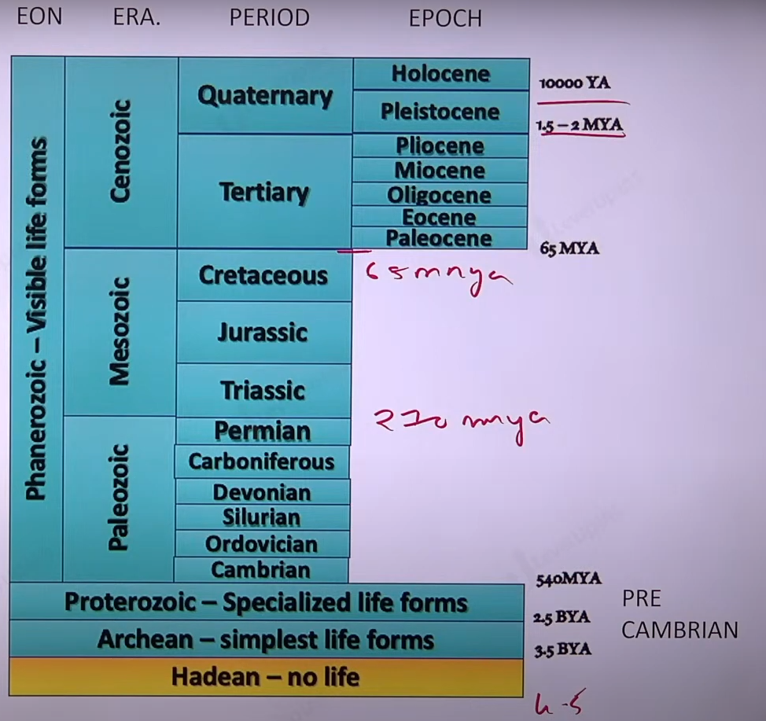

CONTINANTAL DRIFT THEORHY:

Geological time scale

1. It is a system of dating features of earth geological and life form to know the time of important event. Like formation of coal formation of life, the idea of continental drift.
2. Dating is done with the help of rock c-14 isotopes and uranium lead isotopes
3. Earth is 4.6-billion-year-old but proper formation and important event began 3.5 billion years ago.

Geological time scale is mainly divided in four division.

1. EON
2. ERA
3. PERIOD
4. EPOCH

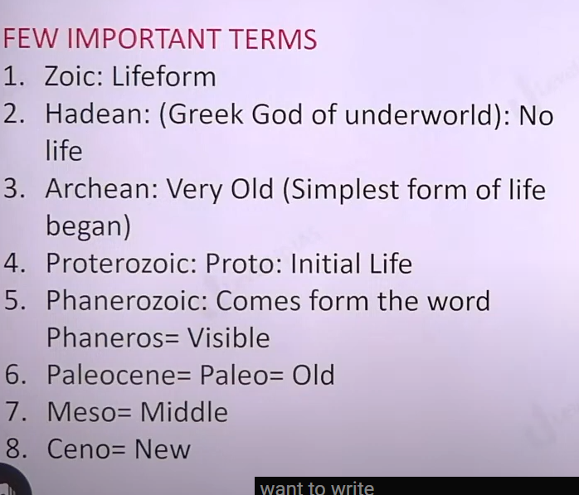

ARCHEN formation earthen ghat and Aravali.

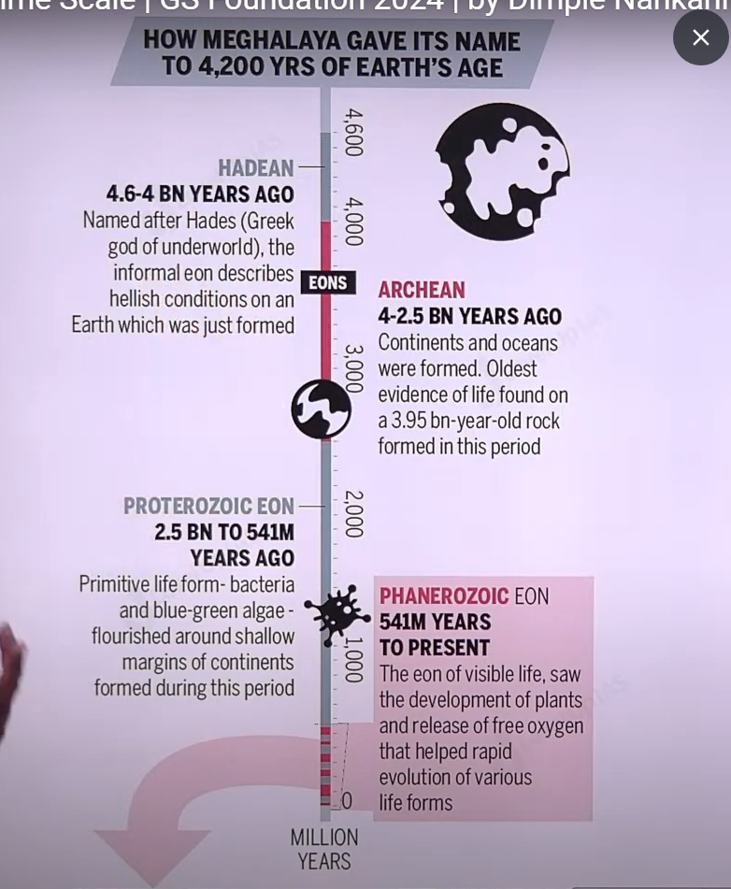

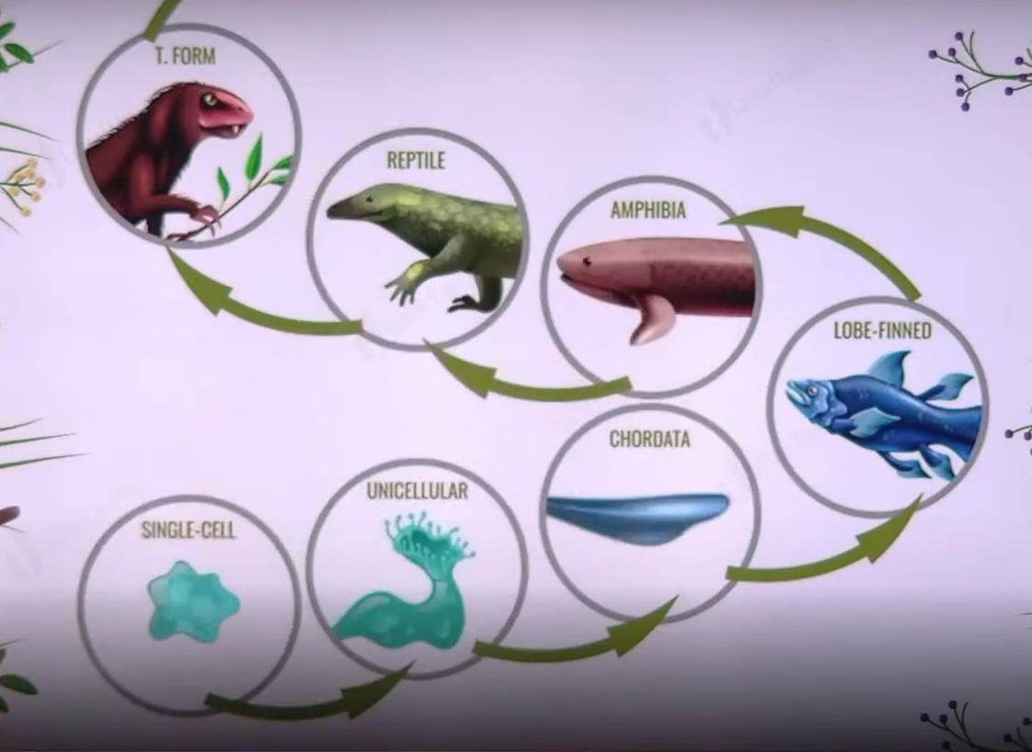

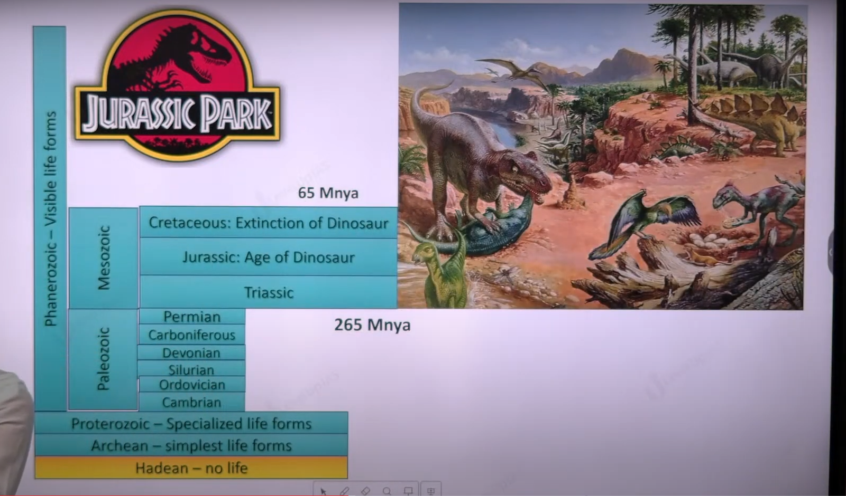

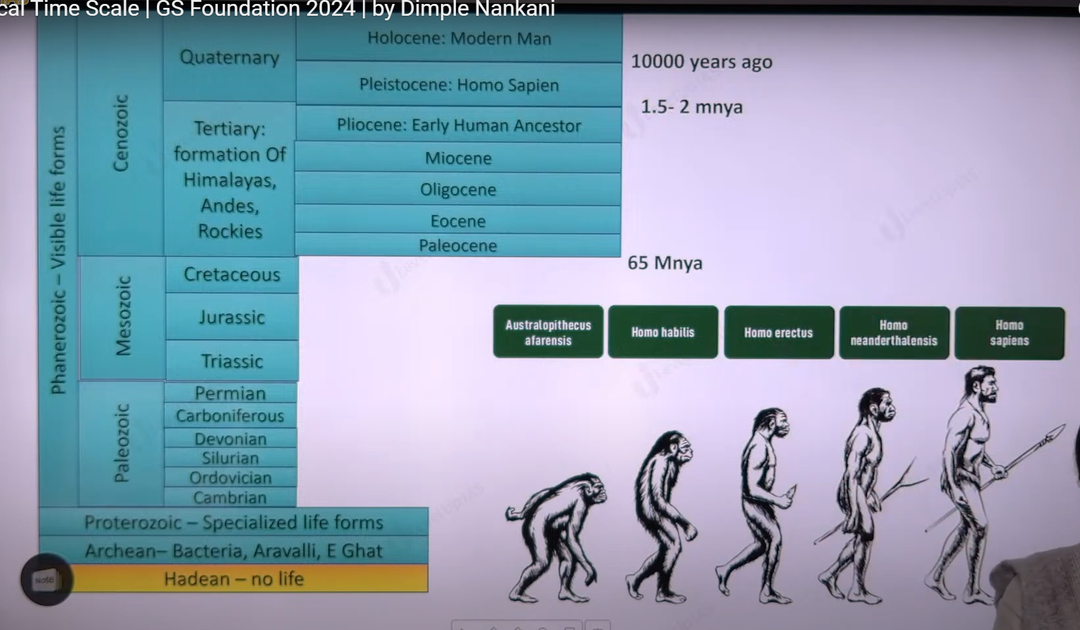

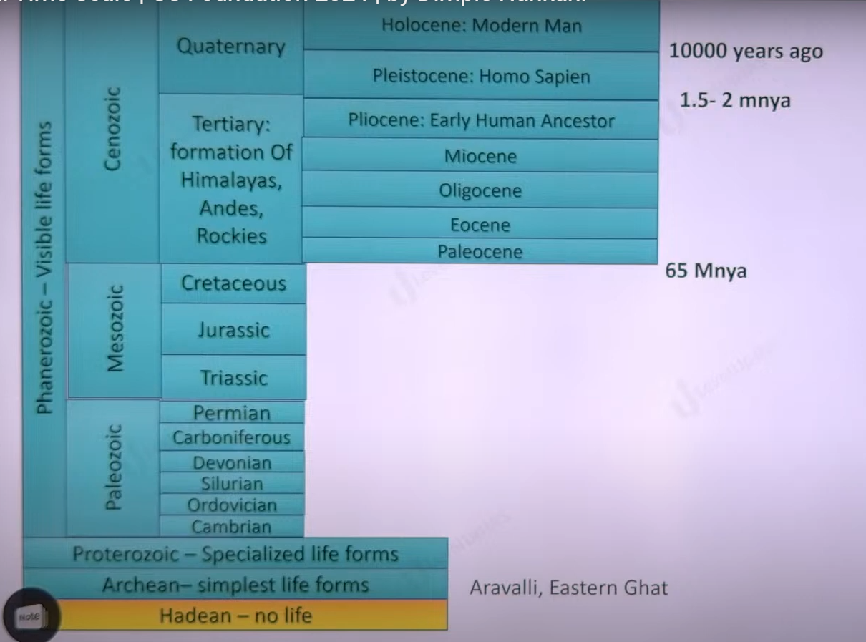

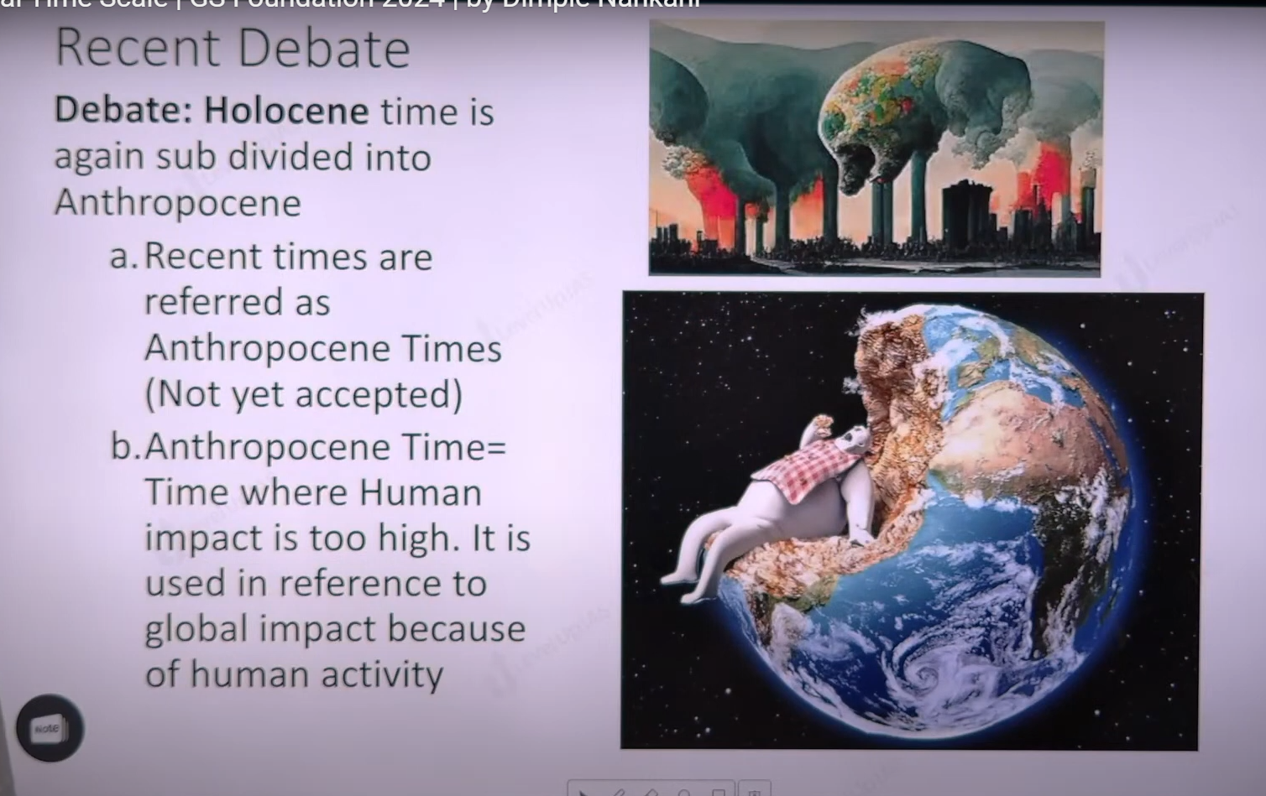

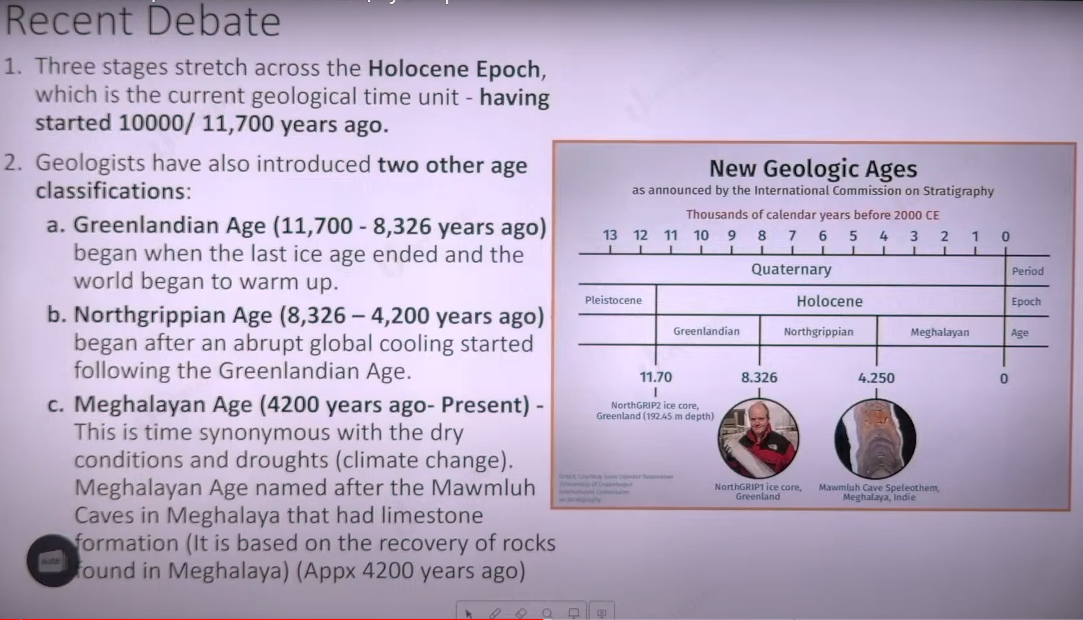

Speleothems:

Recent debate:

Inclusion of new age within epoch the 3 ages included Holocene epoch are

1. Green landing age
2. Northgrippen ages
3. Meghalaya ages:
   1. 4200 year ago it synonyms with dry conditions and drought it named after mawmluhm caves. The cave has lime stone and shows evidence of dry conditions there may correlation with the dry conditions and collapse of cavillation in Egypt Syria indus valley Mesopotamia and yanse (china) river valley.

Second debate is renaming the Holocene to Anthropocene it aims to show effect of man on the earth.

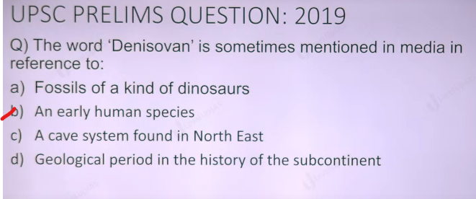

Geography is study of earth as it home of man therefore it important to study of physical features, rock mineral climate parameter and resource of ocean. Distribution of lifeforms animal, plant, study of settlement, the population characteristics.

Rocks and minerals

Element = hydrogen

Mineral =composition sio2 , caco2,dimand c4 definite.

Rock = composition is not fixed.

Major element is silicate of crust.

Element mineral and rocks

An element is substance that cannot be subdivided by non-nuclear reaction.

The elements can be combined in many ways they form minerals. On the earth surface 2000 minerals were found. How ever only 6 group dominate the earth crust i.e. sulfates, silicate, halide(halogen) carbonates, oxides ,sulfides. Mainly silicate group that dominate.

Minerals are naturally occurring inorganic structures having an orderly atomic structure and definite composition and physical properties.

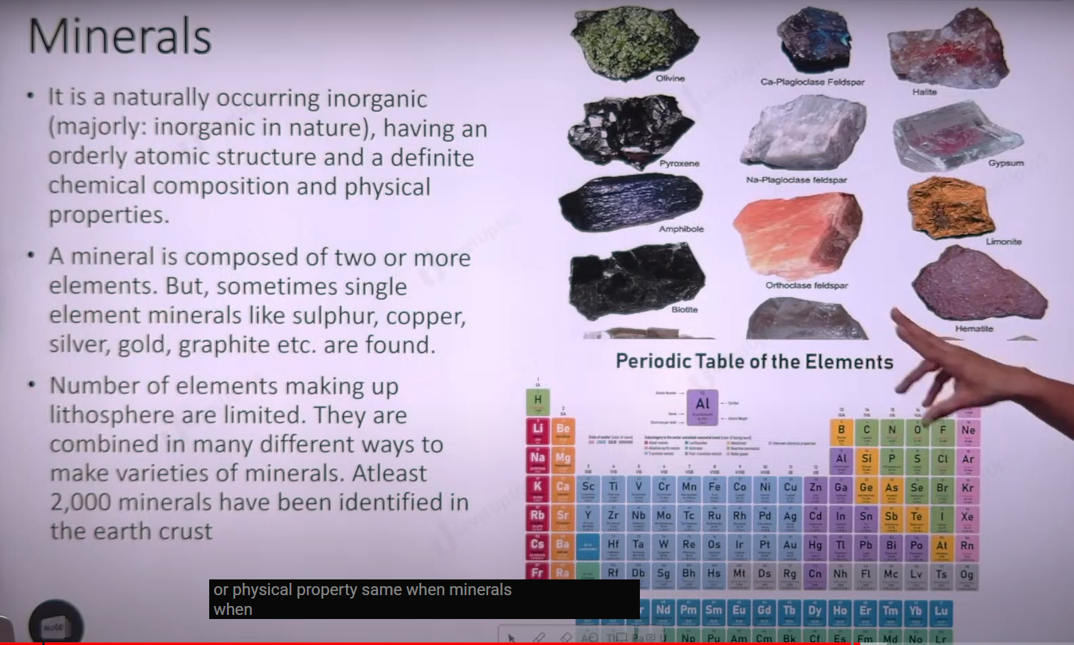

Rocks are natural aggregates of minerals although they do not have definite chemical composition.

The sources of minerals is hot magma. When the magma cools it solidifies and become ingious rocks which have many minerals.

Type of rocks:

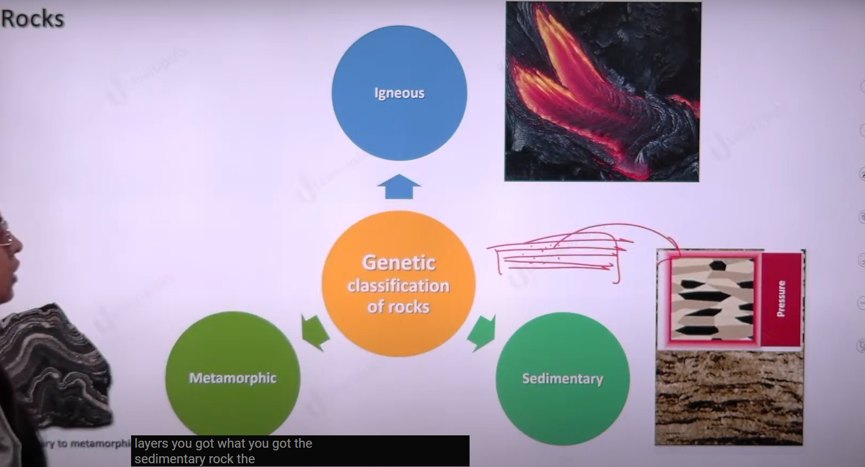

Genetic (genesis) classification

1. Igneous rock (primary rocks)
2. igneous means fire.
3. They are formed due to cooling solidification of molten magma or lava.
4. They are crystalline in nature.
5. Non fossiliferous, unstratified (cannot create layers).
6. Crystalline (definite structure of molecule.)
7. Example granite, gabbro, basalt pegmatite, volcanic braais, andesite, komatiite, diorite, rhyolite, peridotite.
8. Igneous rocks can be classified into intrusive and extrusive rocks based on location.
9. Those igneous rocks that are formed by cooling of magma inside the earth crust is called intrusive igneous rocks, ex. Granite
10. The rocks that are formed from the cooling of magma above the earth surface is called exclusive igneous rocks ex. Basalt
11. On the basic of the size of crystals can be classified into two types.
    1. Fine crystalline rocks: crystals are not visible to naked eye ex basalt
    2. Large crystalline rocks: crystals are visible to the naked eye ex granite.
12. Generally extrusive igneous rocks are fine crystals while intrusive rocks have large crystals.
13. igneous rocks can be classified on silica content.
    1. Acidic rocks have more of silica
    2. Basis rocks have less silica.

Q. describe the characteristics and type of primary rocks.

Intro define the rocks

Body :

Type

Characteristics

Conclusion: importance of igneous rocks. Granite is used in building materials. Minerals hub.

IF magma has more silica then the magma is viscous/stickiness, when the magma has less silica then the magma flow more and less viscous.

More silica from volcanoes, less silica from the plateau.

They are resistant to weather and erosion. They are skin aid and dental care aid. They are solid conditioners. Sedimentary rocks.

Sedimentary rocks:

They are formed because of deposition of segment of rocks by exogenic process. Stages involve weathering, transportation and deposition of sediment compaction of sediment, cementation and binding of rock and lithification of rocks.

Characteristics are

1. They are layered, fossil , they are not crystalline in nature , ex sand stone limestone clay, Calk.

There are 3 modes of formation

1. Mechanical formed.
2. Organically formed
3. Chemically formed
4. 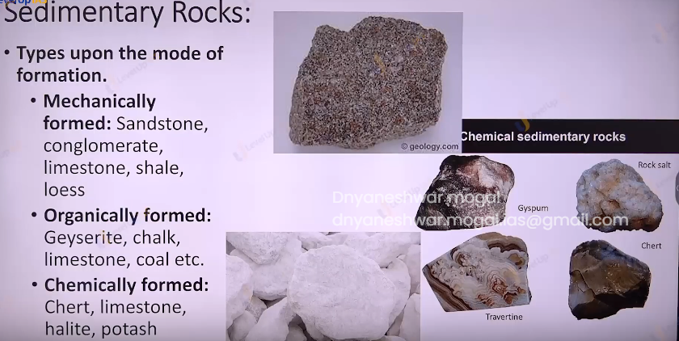

Sedimentary rocks help us understand animals and life chains, they are used in the construction building material. Ex limestone is raw material for Portland cement. Sedimentary rocks petroleum and natural gas reservoirs.

Metamorphic rock (change of forms)

Sediment and igneous rocks witness the extreme change in pressure and temperature and volume. Original rocks can undergo re crystallization and reorganization to form metamorphic rocks.

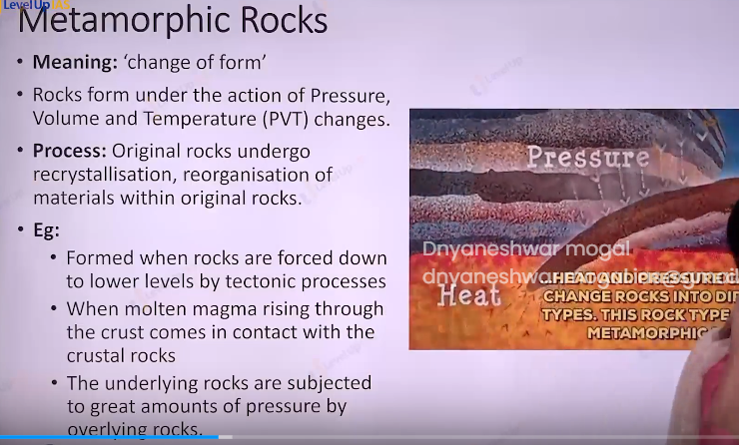

Ex.

Type of metamorphic rock

1. Dynamic metamorphism: changes in the rocks because of pressure changes.
2. Thermal metamorphism: changes in the rocks because of thermal mechanism
   1. Contact metamorphism: rocks come in contact including magma undergo recrystallization under high temperatures.
   2. Regional metamorphism: rocks undergo recrystallization due to tectonic reasons

Characteristics of metamorphic rocks:

1. They can be arranged in the layers called foliaged ex. Gneiss, slate, phyllite, marble
2. They are banded or foliated but they are not layered.
3. They are crystalline and they are fossiliferous.

Importance of Metamorphic rocks:

1. They used as building material, construction work, cosmetic, dental care.
2. 

Rocks cycles.



Rocks undergo transformation from one from to another this is called as rocks cycle.

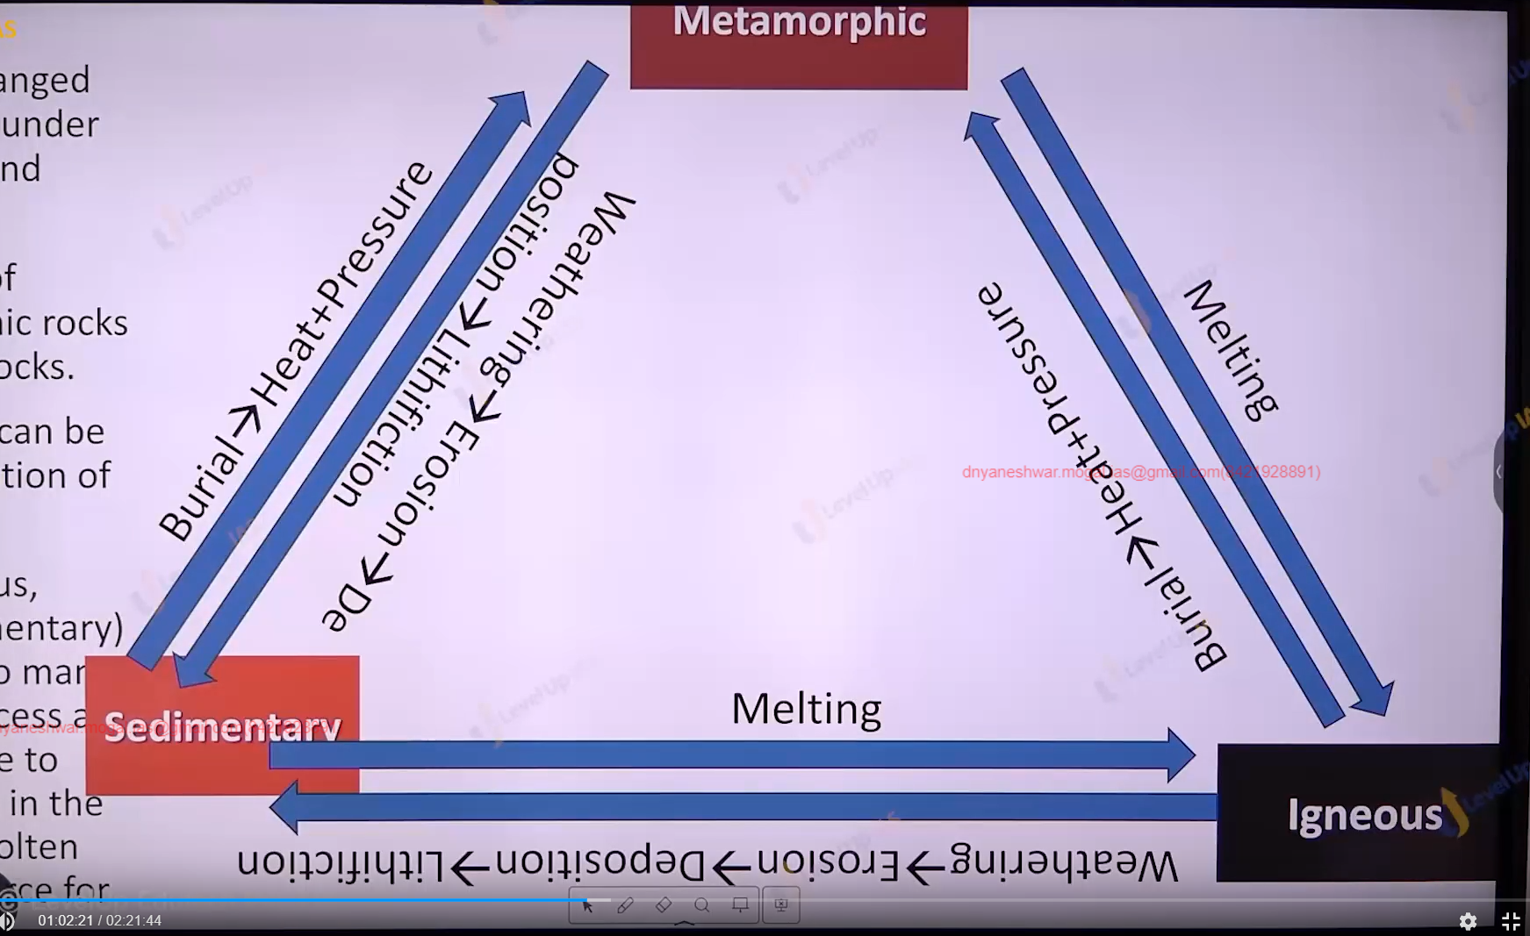

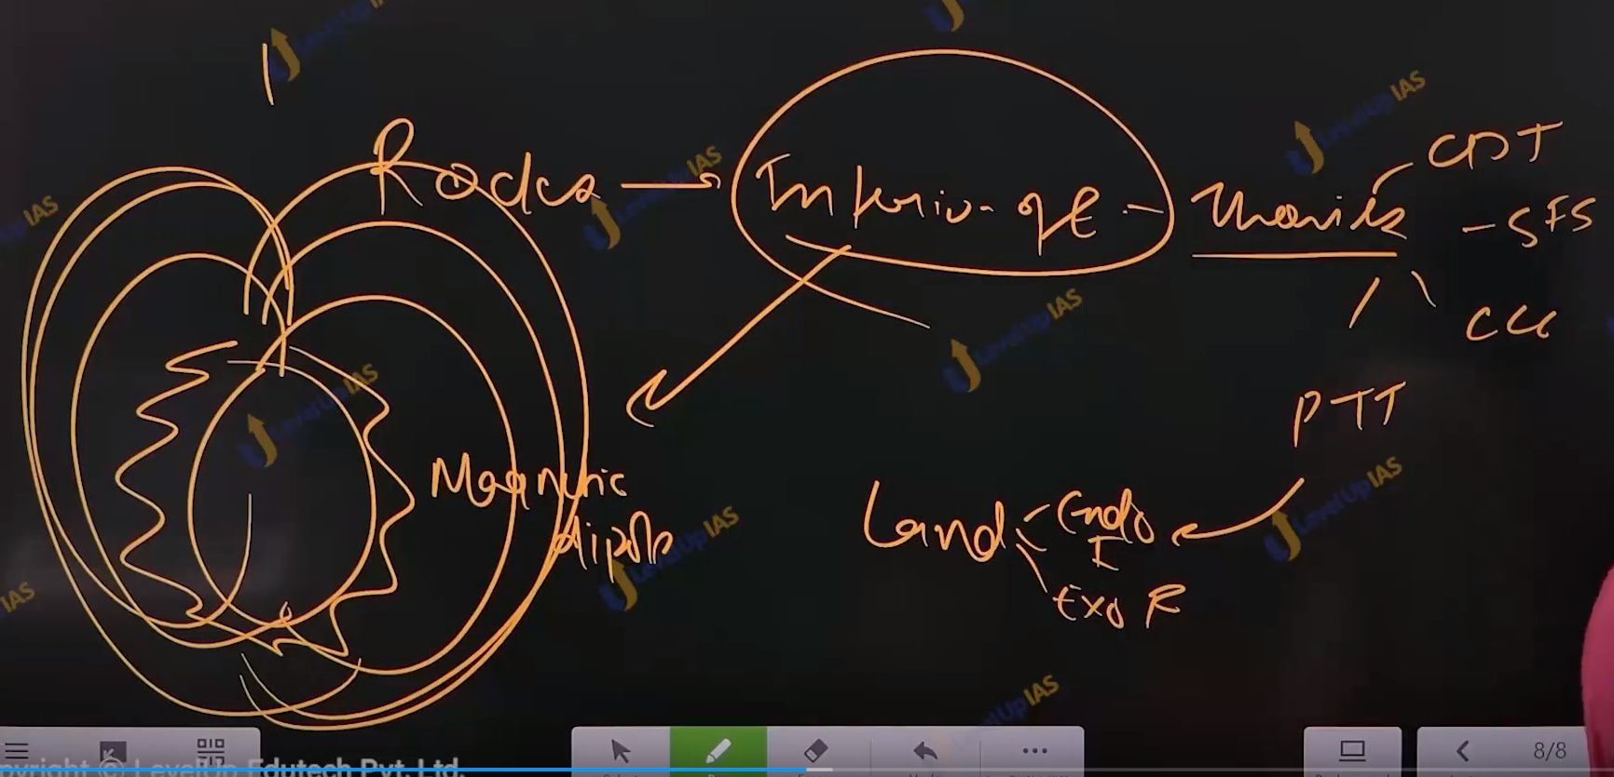

\

**************** INTERIOR OF EARTH*************************

Earth is not monolith earth has layed structure layering is on the basis of density this is known as density stratification. Overall density of earth is 5.5 and density of earth is increasing as we move in the inner layer. Density of crust is about 2 to 2.5 where the density of mental 5.9 and the density of core 11 to 13.

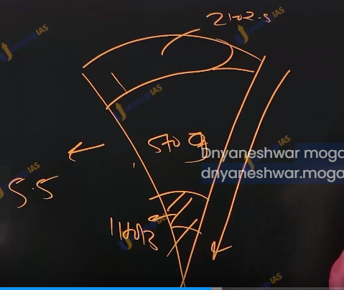

The density stratification is explained by nebular hypothesis density is increase due to above layer and because of composition of the rocks.

Element in the earth’s interiors:

Element in the overall earth iron 35% oxygen30% silicon 15 % magnesium 13%

Rest is other 7%.

The major element in the earth’s crust is oxygen 46% silicon 27% aluminums 8% iron 5% calcium 3%.

Element in the mantal are oxygen silicon aluminums

Element in the earth’s core iron and nickel and aluminum.

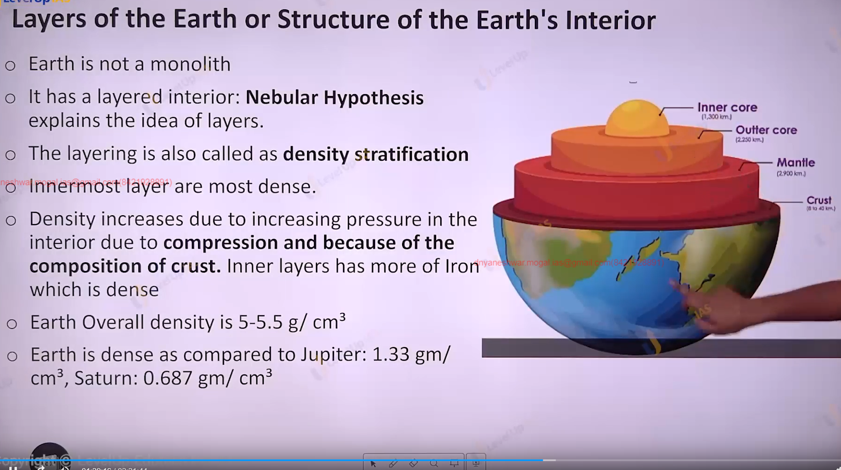

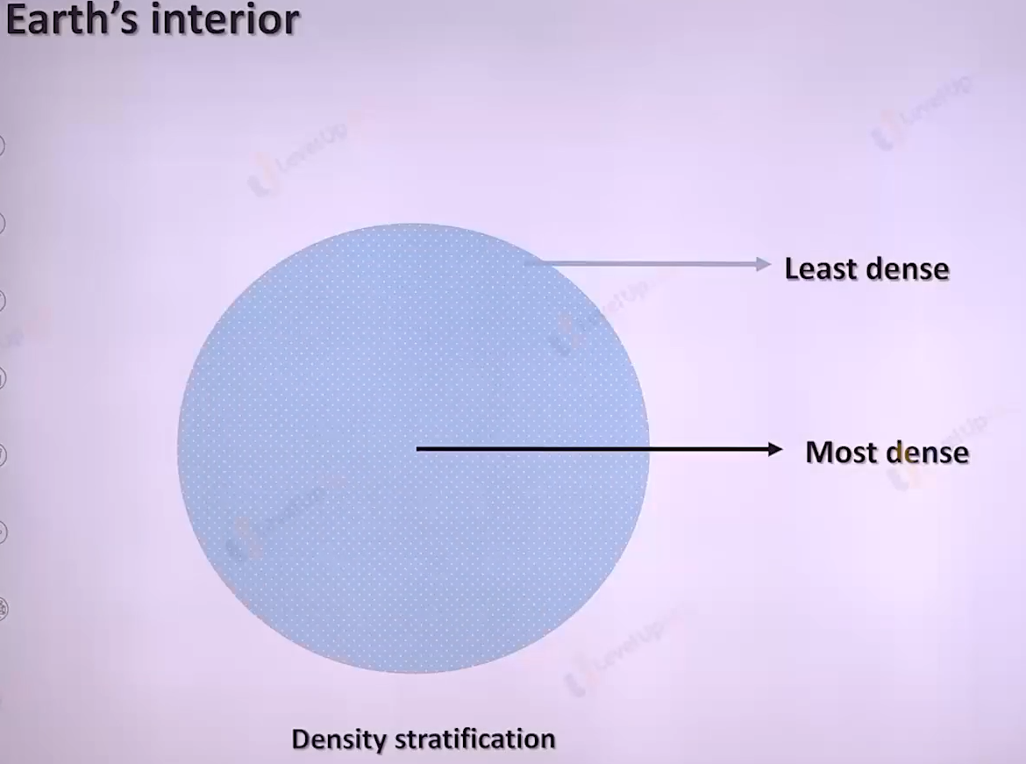

Mental and outer core both have the silicate, but they are different kinds mentals silicate are started to flow under the pressure they way mental is in liquid form or lava like form.



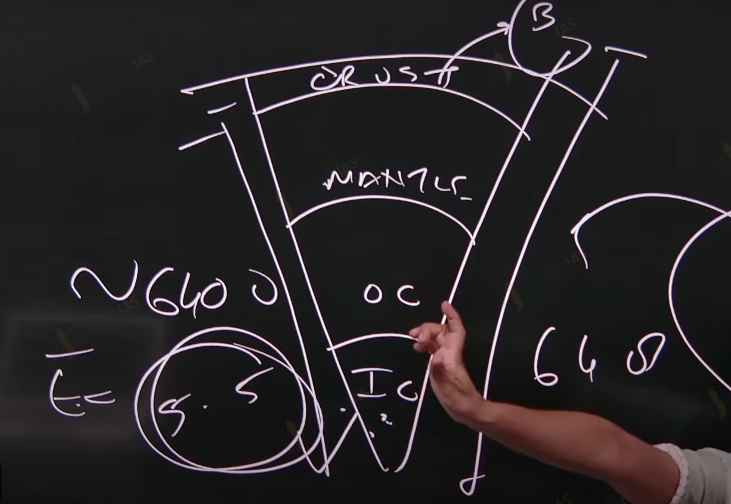

if magma has more silica magma vicious and stick ex granitic magma. Can form Plato

When the magma has less silica magma Is flowing in the nature. Can form volcano or mountain.

Important of igneous rock:

They are resistance to weathering and erosion as compared to sedimentary rock. They are used in skin aid and dental aid ex pumice rock. They are used soil conditioner.

Sedimentary rock: they are formed because of deposition of fragments of the rocks by exogenous process. Stages involve are weathering(breaking down rock) transportation and deposition of rocks , compaction of sedimentation , cementation , binding of rock/partials and lithification.

characteristic of sedimentary rock.: characteristic they are layered has fossil and they are not crystalline in nature ex samsonite, limestone clay, chalk.

There 3 modes of formation mechanically formed, organically formed, and chemically formed.

Mechanically : sand stone limestone

Organically formed: chalk, limestone ,coal.

Chemically formed : limestone halite , potash.

Importance of sedimentary rock ::

1. they help us understand the evolution of animals and climate change.
2. They used in construction materials ex. Limestone raw material for Portland cement .
3. sedimentary rock petroleum and natural reservoir.

Petroleum formed anaerobic decomposition of marine animals. Coastal reason Mumbai , Gujrat.

Metamorphic rocks: it is derived from the word metamorphosis (change in the forms) sedimentary rock and igneous rock witness extreme change in pressure, volume and temperature.

Process: original rock undergoes recrystallisation reorganization to form meta morphic rock.

Type of metamorphism :

1. Dynamic metamorphism : changes in the rock because of pressure changes.
2. Thermal metamorphism : changes in the rock formed because of temperature changes.
   1. Contact , regional.
   2. Contact metamorphisms: rocks comes in contact of including magma to undergo recrystallisation
   3. Regional metamorphism; the rocks undergo recrystallisation due to tectonic reasons.

Characteristic of metamorphic rock

* + - They can be arranged in the layers called as foliation ex: gneiss, slate, phyllite, marble.
    - They are banded or foliated but they are not layered
    - They are crystalline and they fossiliferous.

Importance of metamorphic rock :

* They are used building material construction work , cosmetic , in dentalcare etc.

Rock cycle : the rocks undergo transformation and changed one form to another this called rock cycle.

Metamorphic

Burial -> Heat pressure

Burial -> Heat pressure

Weathering -> erosion -> deposition -> lithification

Melting

Weathering -> erosion -> deposition -> lithification

Melting

igneous

Sedimentray

Interior of earth :

1. Earth is not monoliths , earths has layered structure . layering is basis of density this is know as density stratification.
2. Overall density of earth is about 5.5 and density of earths increases as move from surface to inner layers ex . density of crust is 2 to 2.5 where density of mental is about 5-9 and density of the core 11 to 13.
3. Density stratification is explained by nebular hypothesis, the density increase due to increasing pressure from the above layer and also because of composition rocks.

Elements in the earths interiors overall :

Iron 35 % oxygen 30% silicon 15% magnesium 13% other’s 7%

The major element in earth’s crust oxygen 46% silicon 27% , alluminium8% iron 5% calcium 3%.

Elements in the mental oxygen silicon’s aluminum calcium , and earth’s core iron Nicol,aluminum.

Edward Suess classification :

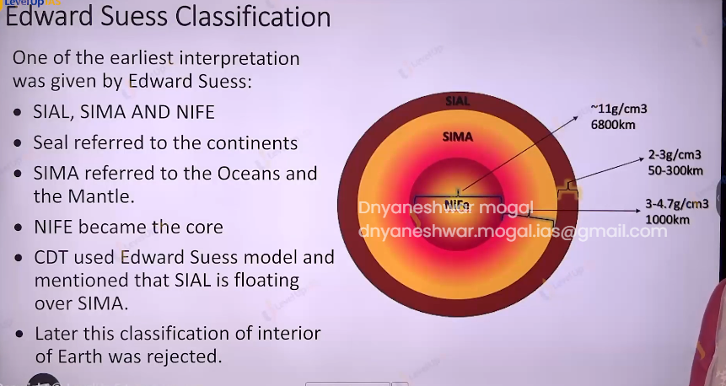

It is one of the earliest interpretations given by Edward Suess.

SIAL: referred to continents

SIMA referred to the oceans and the mental

Nife became the core.

Continental drift theory used Edward Suess model and mentioned that SIAL is floating over SIMA.

Later this classification of the interior of the earth was rejected.

Present day understanding:

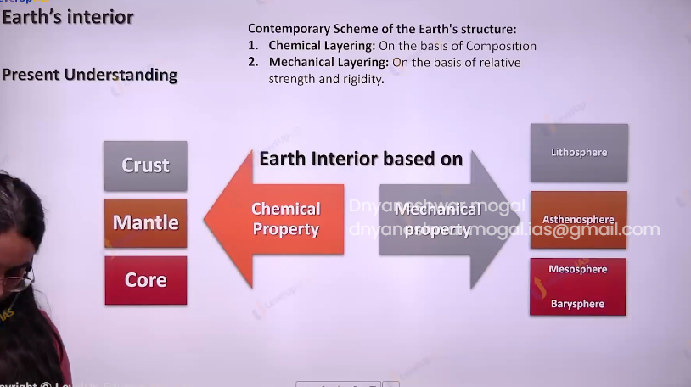

* Layering of earth’s based on chemical property crust, mental, core.
* layering on the basis of mechanical property rigidity fluidity strength that is lithosphere, asthenosphere, mesosphere , barysphere.

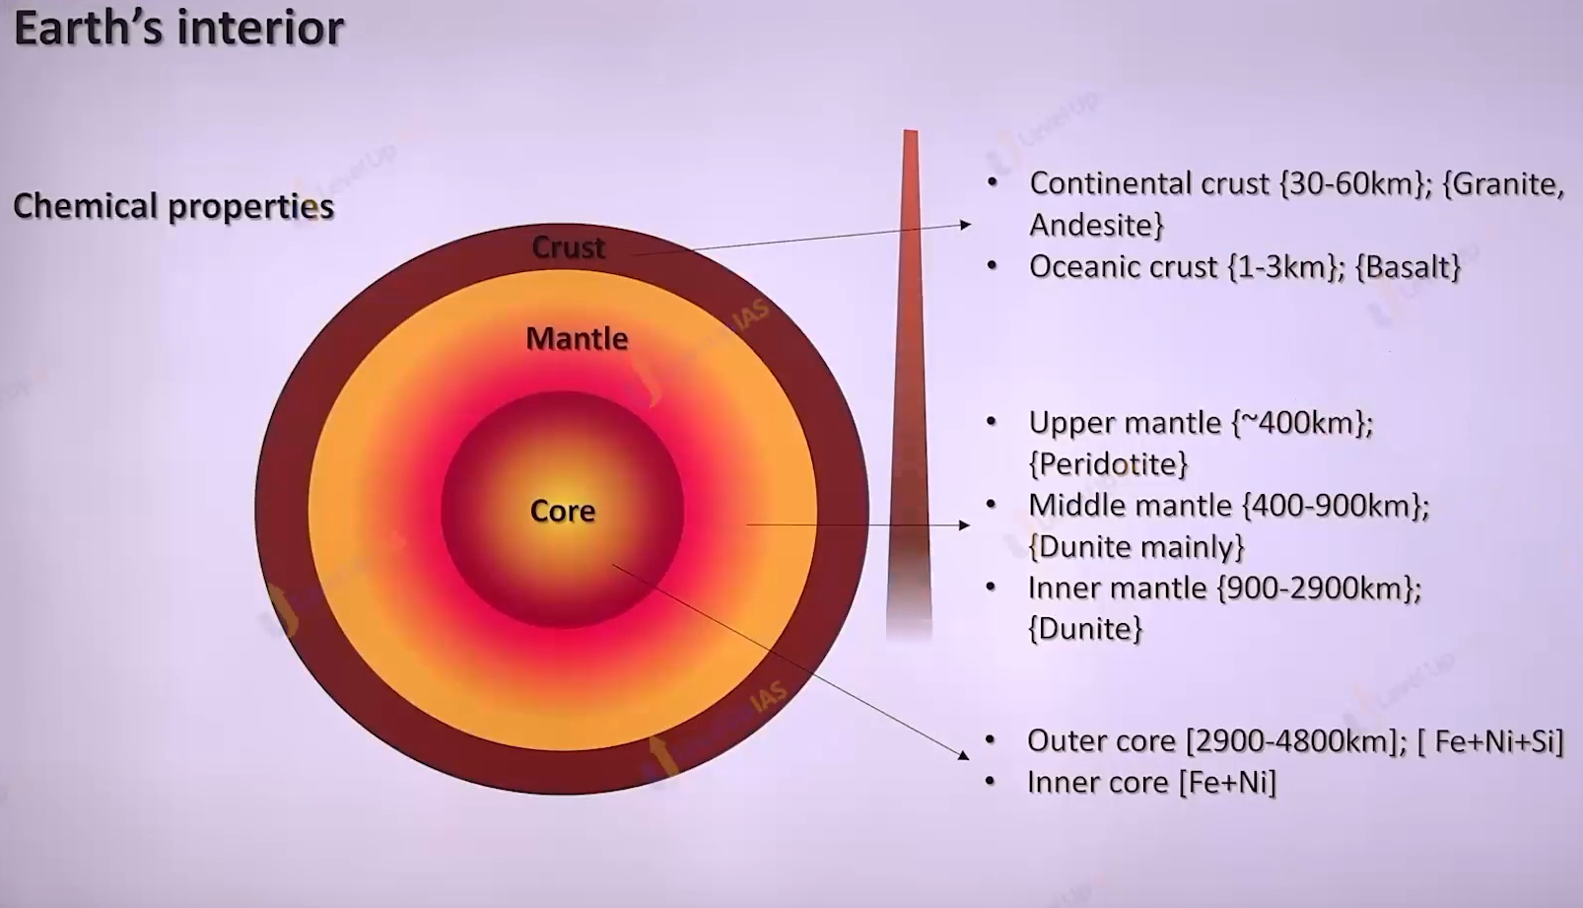

Layering on the basis of chemical properties.

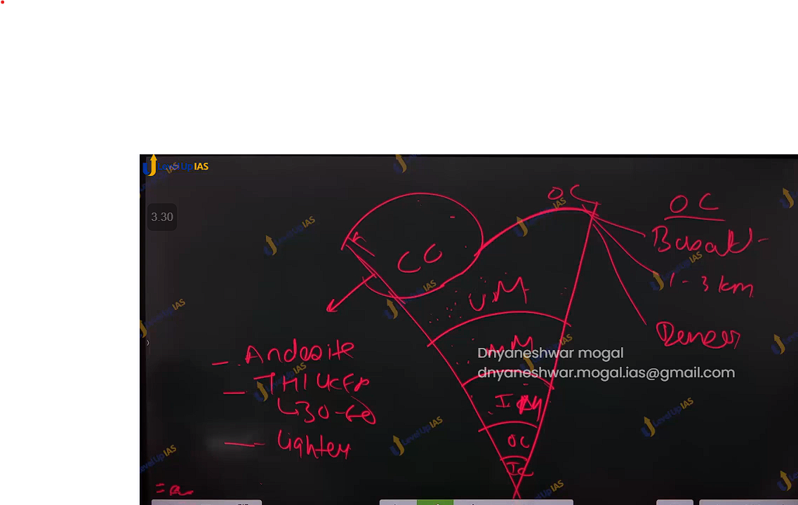

Crust :

It is outermost layer and also the lightest among all.

On an average thickness in 17-20 km.

it can be divided into continental crust and oceanic crust.

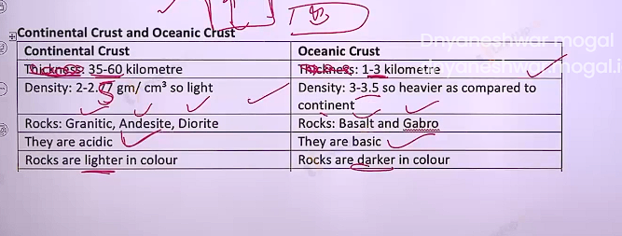

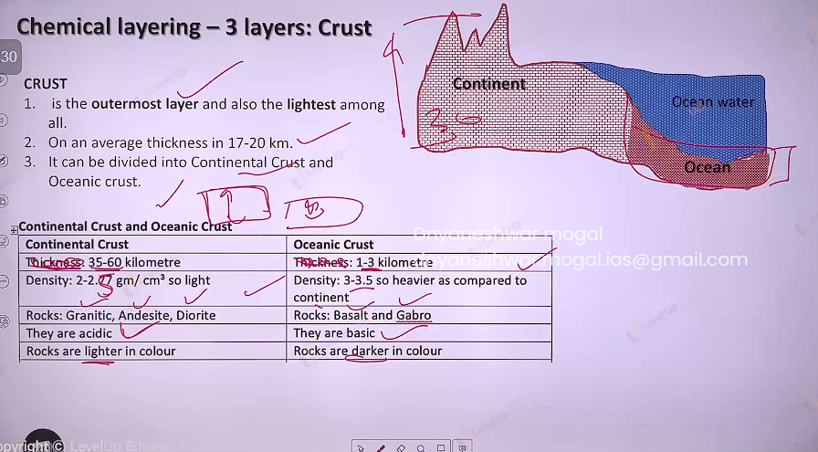

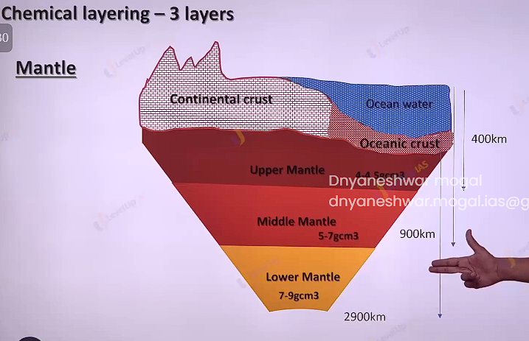

Mental :

It is second layer in the earth’s interior heavier than crust and lighter than core. Accounts 80% of volume 70% mass of earth’s extends from 100 to 2900 km. it can divided in 3 part upper ,middle and lower mantal.

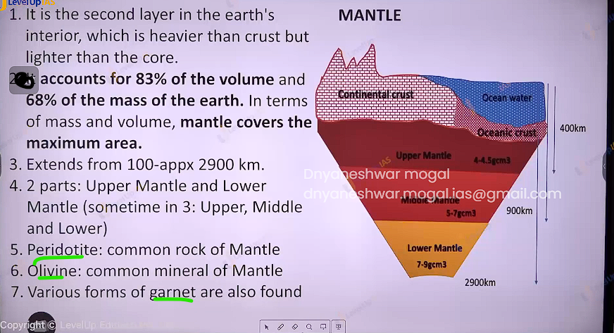

CORE :

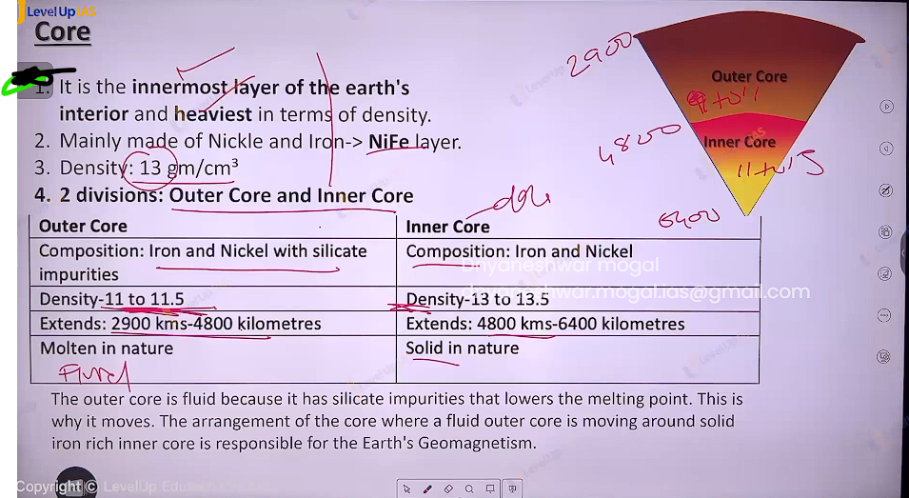

**Interior of Earth and Evidence of Interior of Earth**

THE Arrangement of outer core and inner core where fluid outer core is moving around solid iron rich inner core is responsible for earth’s magnetisms . the outer core fluid while inner is solid because of silicate impurities. Silicate impurities reduce the melting point.

Geo magnetisms:

Earth behaves magnetic dipole earths has magneto sphere which extents up to 60,000 km around the surface.

Importance of geo magnetisms:

1. The birds , fishes use the magnetic field of the earth for their movement
2. Magnetosphere protect earths from harmful effect of solar wind , which are cable of striping the planet of life.
3. The interaction of magnetic field of the earths with solar winds also produces bright lights near north pole and south pole called as aura Australis aura borealis.

The origin of geo magnetism

The earth’s outer core is fluid and rotating around solid iron rich core , outer core is extremely hot and it is in plasma state 4500 degree Celsius. And electrons are free and move easily . The outer core is moving around the inner core implying electron moving around iron rich inner core .outer core can spin because earths core this arrangement is like geo electric magnetic (elector magnet).

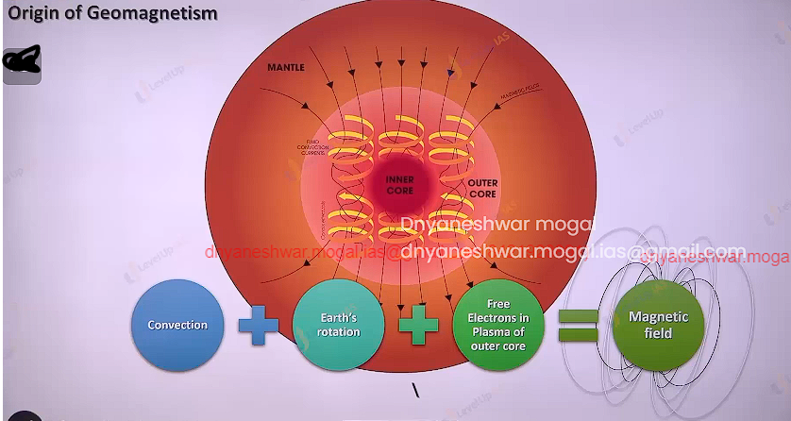

Variation in the magnetic field:

1. Location of the magnetic pole can be change
2. Intensity of the magnetic field can vary.
   1. Sometime the magnetic field can be very strong
   2. Sometime magnetic field an weaken and sometime disappear
3. Magrnetic fields is know to reverse
4. Magnetic axis is not perfectly aligned with the geographic axis.

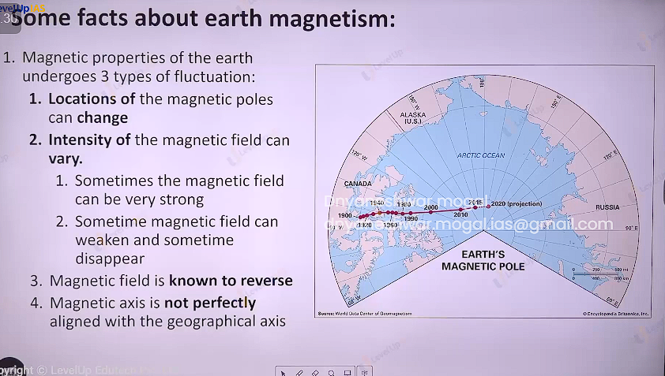

Layer on the basis of mechanical property.

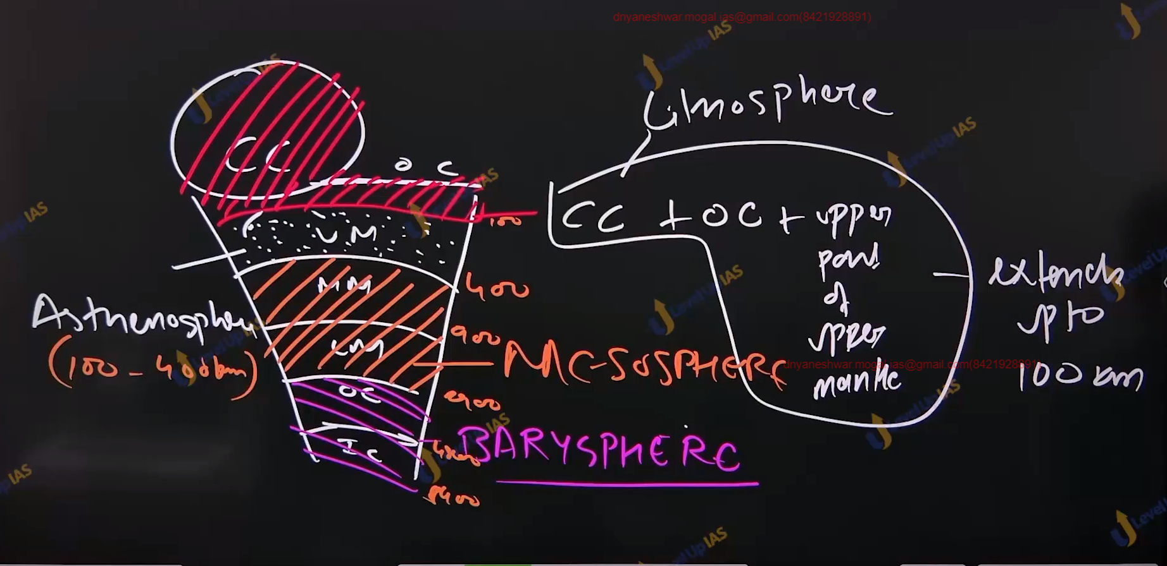

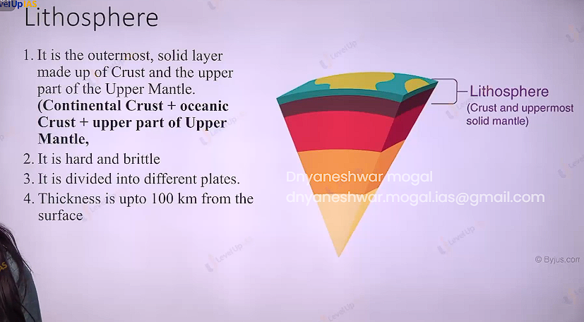

Lithosphere is hard brittle and it can divided into different plate thickness 100 km.

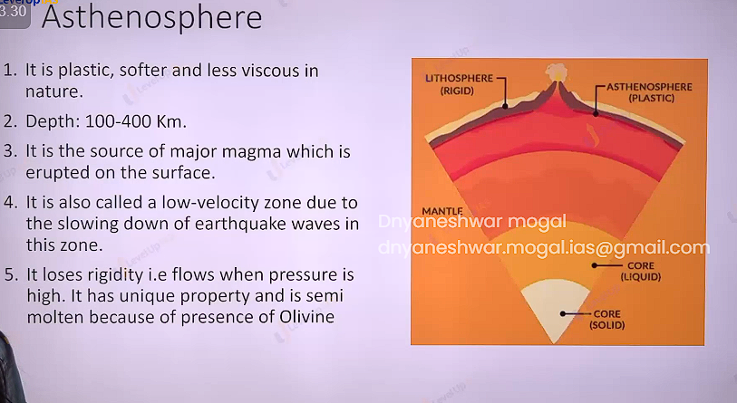

Asthenosphere is plastic softer less viscous in nature. It source of magma it losses rigitdity when the pressure is high this property is because of polibine.

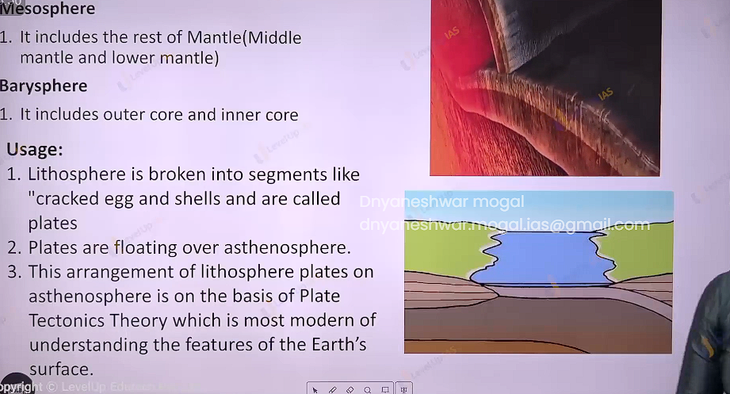

Usages of interiors of earths :

Lithosphere is Brocken into segments like crack egg shell and called plate. The arrangement of lithosphere over the asthenosphere is basis of plate tectonic theory.

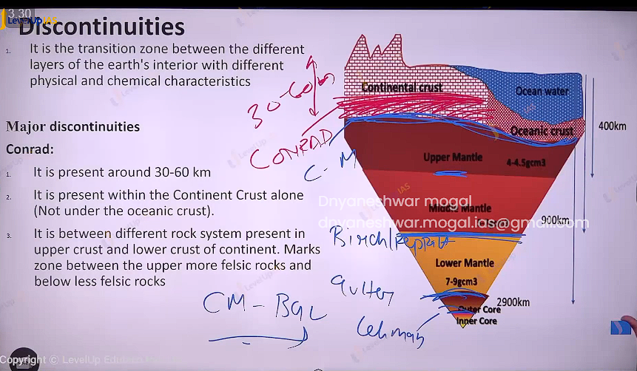

Discontinuities

It is transition zone between the difference layer of earth’s interior with different physical and chemical characteristic .

Conrad : 3060-km

1. It is present around 30-60 km
2. It is present within the continent crust alone
3. It is between different crock system present in the upper crust it and lower crust of continent marks zone between the upper more felsic rock and below less felsic rock

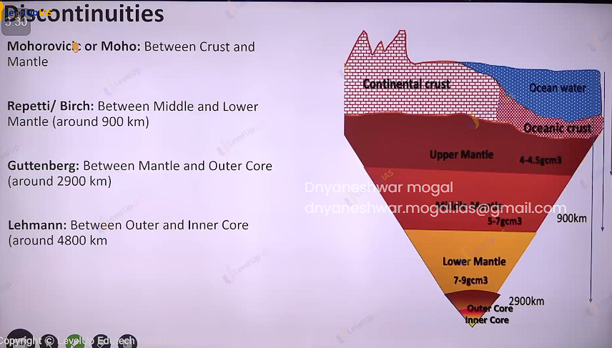

Mohorivic discontinuities:

It is between crust and mental.

Repetti / brich : Between middle and Lower mantle ( around 900 km)

Guttenberg: between Mantle and Outer Core (around 2900 km)

Lehmann: between Outer and Inner Core (around 4800 km )

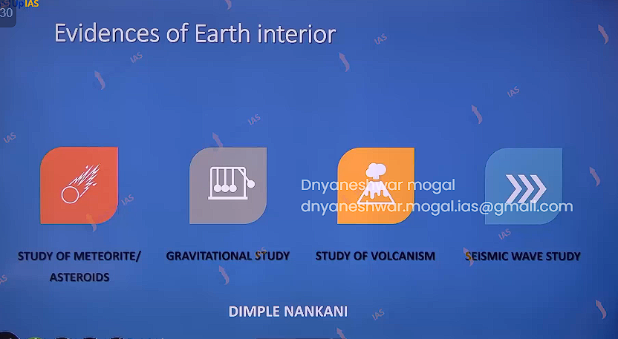



Direct evidence :

There are 2 direct evidences volcanisms and drilling

Volcanisms : volcanism reveals source of magma and kind of minerals present.

Drilling : drilling can provide conclusive proof but the biggest drill has been at kola peninsula near arctic 12 km . however, the interior of the earth 6000 km deep

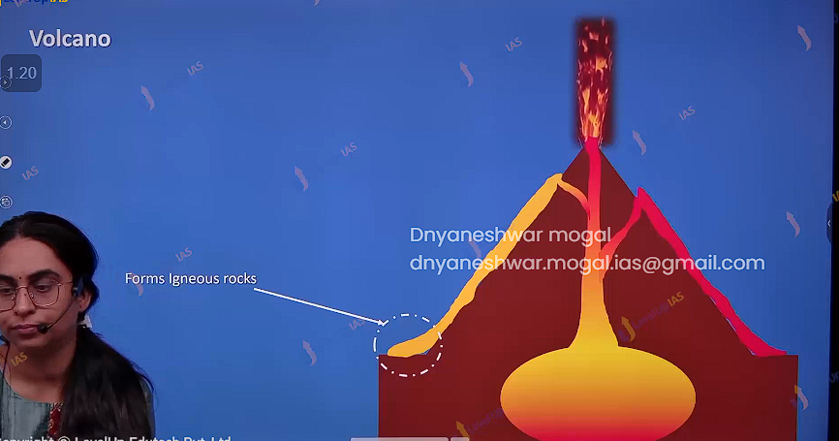

Indirect Sources :

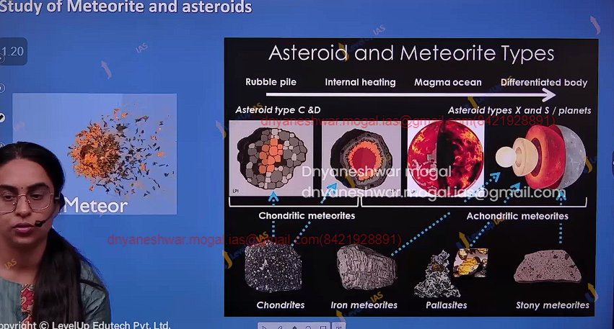

1. Meteoric study: layer nature of the meteoroid reveals the layer nature of the earth ,
2. The pressure density and gravity studies : the distribution of the mass in the earths surfaces has been unequal and via this studies it was acknowledges that inner layer of earth are dense.

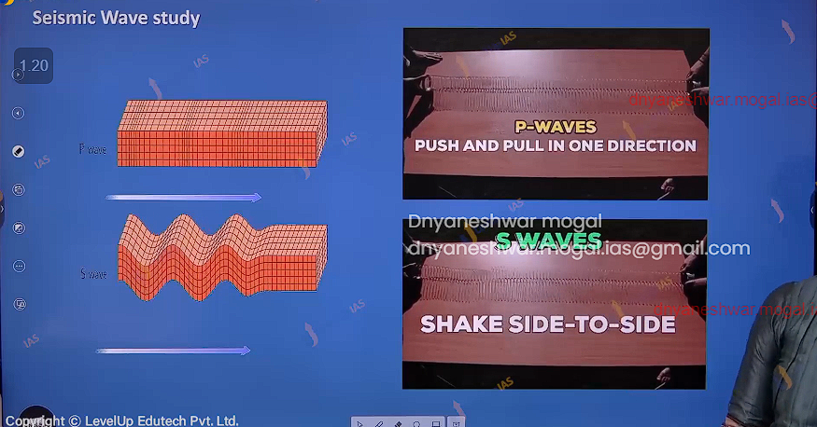

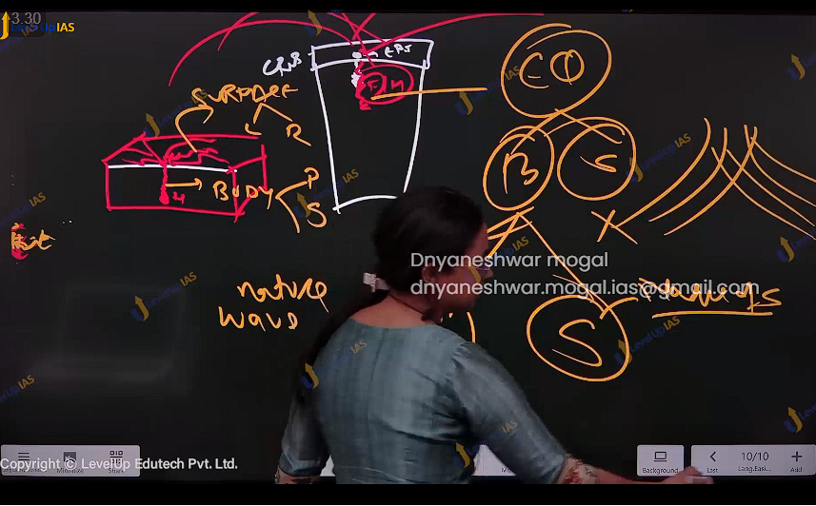

The study of seismic wave is important and confirmatory evidence of earth’s interior.

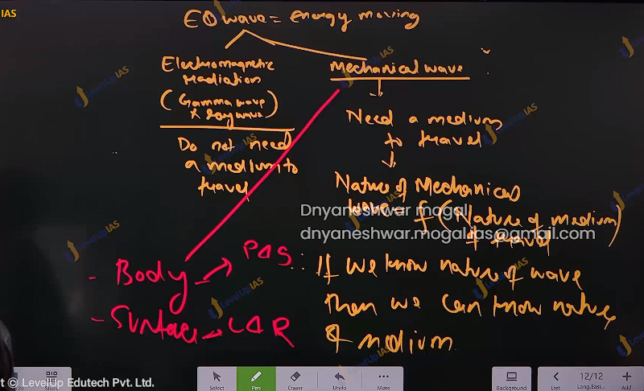

Mechanical wave are of two type: body wave ( p & S) and surface wave( L & R)

To understand the nature of interior of earth it is important to understand the nature of p wave and s wave.

Hypocenter, epicenter :

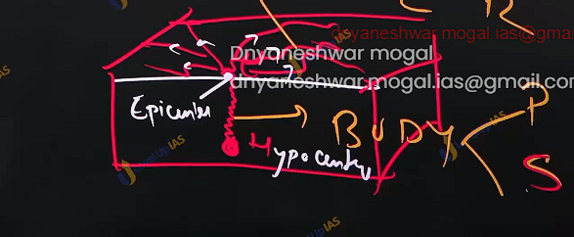

Nature of P wave and S wave:

* P Wave can pass through solid liquid and gas. Where s wave can travel through only in solid medium.
* Both p and s high velocity when high density of medium. In P wave the particle vibrates parallel to the energy transfer while S wave the particle vibrates perpendicular to energy transfer. P wave and s wave bend outwards while they pass from rarer material to dancer material
* The interior of earth can be known by assuming earthquakes focus very near to the earth. This facilitates observation that how the waves changes as they pass through the interior of the earth.

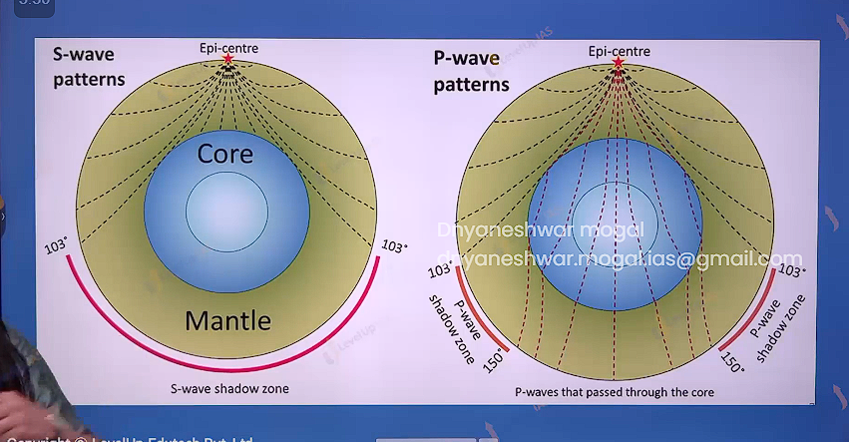

S-wave consistently bends outwards because the density of earth is consistently increasing interior earth.

The S-shadow zone starts from 103 degrees that corresponds to the depth of 2900 km from the surface of the earth.

This implies that there is fluid material beyond 2900 km. This marks the mental core boundary beyond which S -wave can not pass due to fluid outer core.

P- wave pattern.:

There is P-shadow zone starting at 105 degrees because of sudden change in the density at 2900 km.

This marks boundary of lower mentle and outer core. This proves that there is sudden change of density of mental and outer core.

The p wave does not pass though the core because p-wave gets sharply refactor. The p-wave also reemerged at 150 degree after passing through core. these 150 degrees correspond with 4800 km which is boundary between outer and inner core.

The reemergence of p-wave implies that density of outer core and inner core are nearly comparable.